Hunger for truth
3 men from the Iski language understood the gospel in the neighboring language of Itutang and trusted Christ for salvation. As they were hearing the message, their hearts went out to their family and language group. In 2012 they started to gather their families into a new village site in hopes of one day having the teaching come to them. In 2014 God answered their prayer and 2 missionary families and a single lady decided to move into the new village.
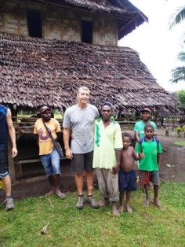
April 10 – 24, I had the privilege to be a part of framing the first house and part of the second one. Never have I been in a village so eager to help with anything we were doing, or so hungry to hear this great message in their own language. They have chosen to lay aside many of their past customs and beliefs, and are waiting to hear. This village of over 300+ people are interested in the gospel, as they have seen God change the lives of so many people in the neighboring Itutang language.

Prayer:
- Iski people to continue to stay hungry for the gospel.
- The 2 families and one single lady would be able to build strong relationships and model Christ as they learn the language and culture.
Praise:
- Rachel has done very well her first year of Bible School. She will be working at a camp for the summer.
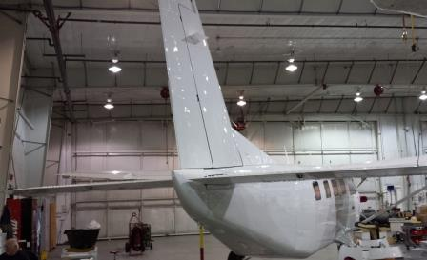
- 2 Donors purchased the first new Kodiak airplane for NTM PNG. It may be in PNG before the year end.
Aaron & Erika Weatherl
Rachel, Micah, Joel, & Grace
